Module Name: Login and Navigation Module
Test Case ID: 183
Webpage URL: https://the-internet.herokuapp.com/

● Scenario ID: 11a
Scenario: Valid Login
Test Steps:
- Open the PyCharm app
- Open PyCharm project
- Open script.py
- Install Selenium – python -m pip install Selenium
- Import Selenium code
- Open Chrome - https://the-internet.herokuapp.com/
- Navigate to Form Authentication
- Enter Username & password
Username: tomsmith
Password: SuperSecretPassword!
- Click login and verify successful login
- Verify the success message
- Click Logout
- Run the complete Python automation
Screenshots:-

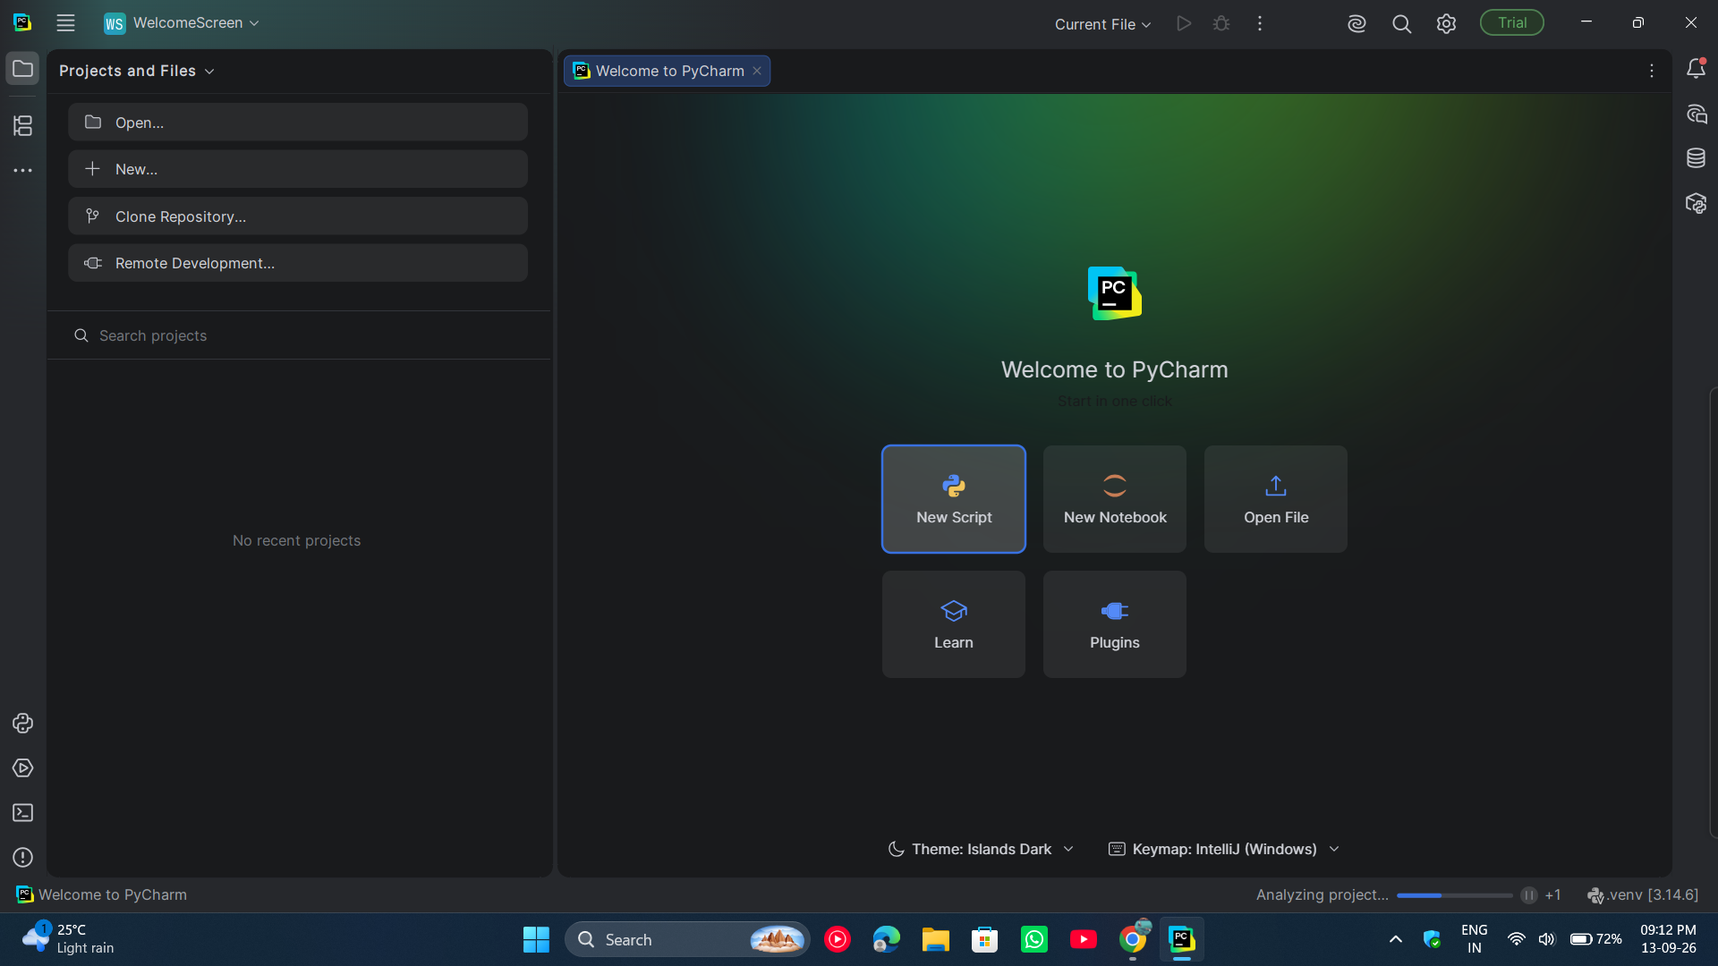l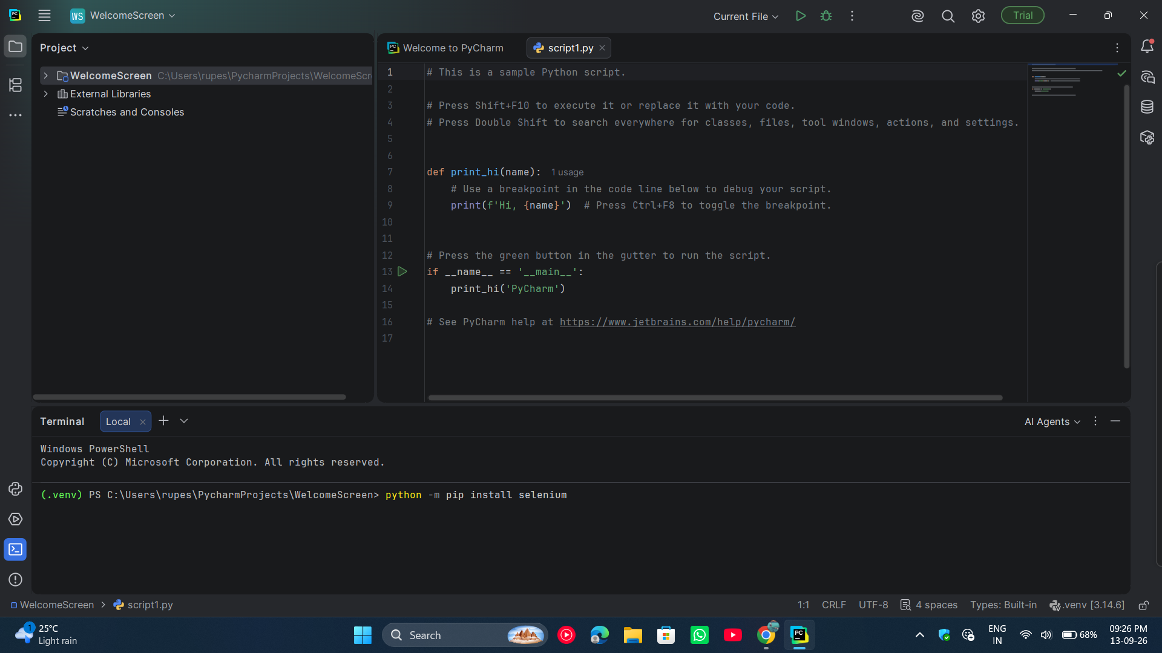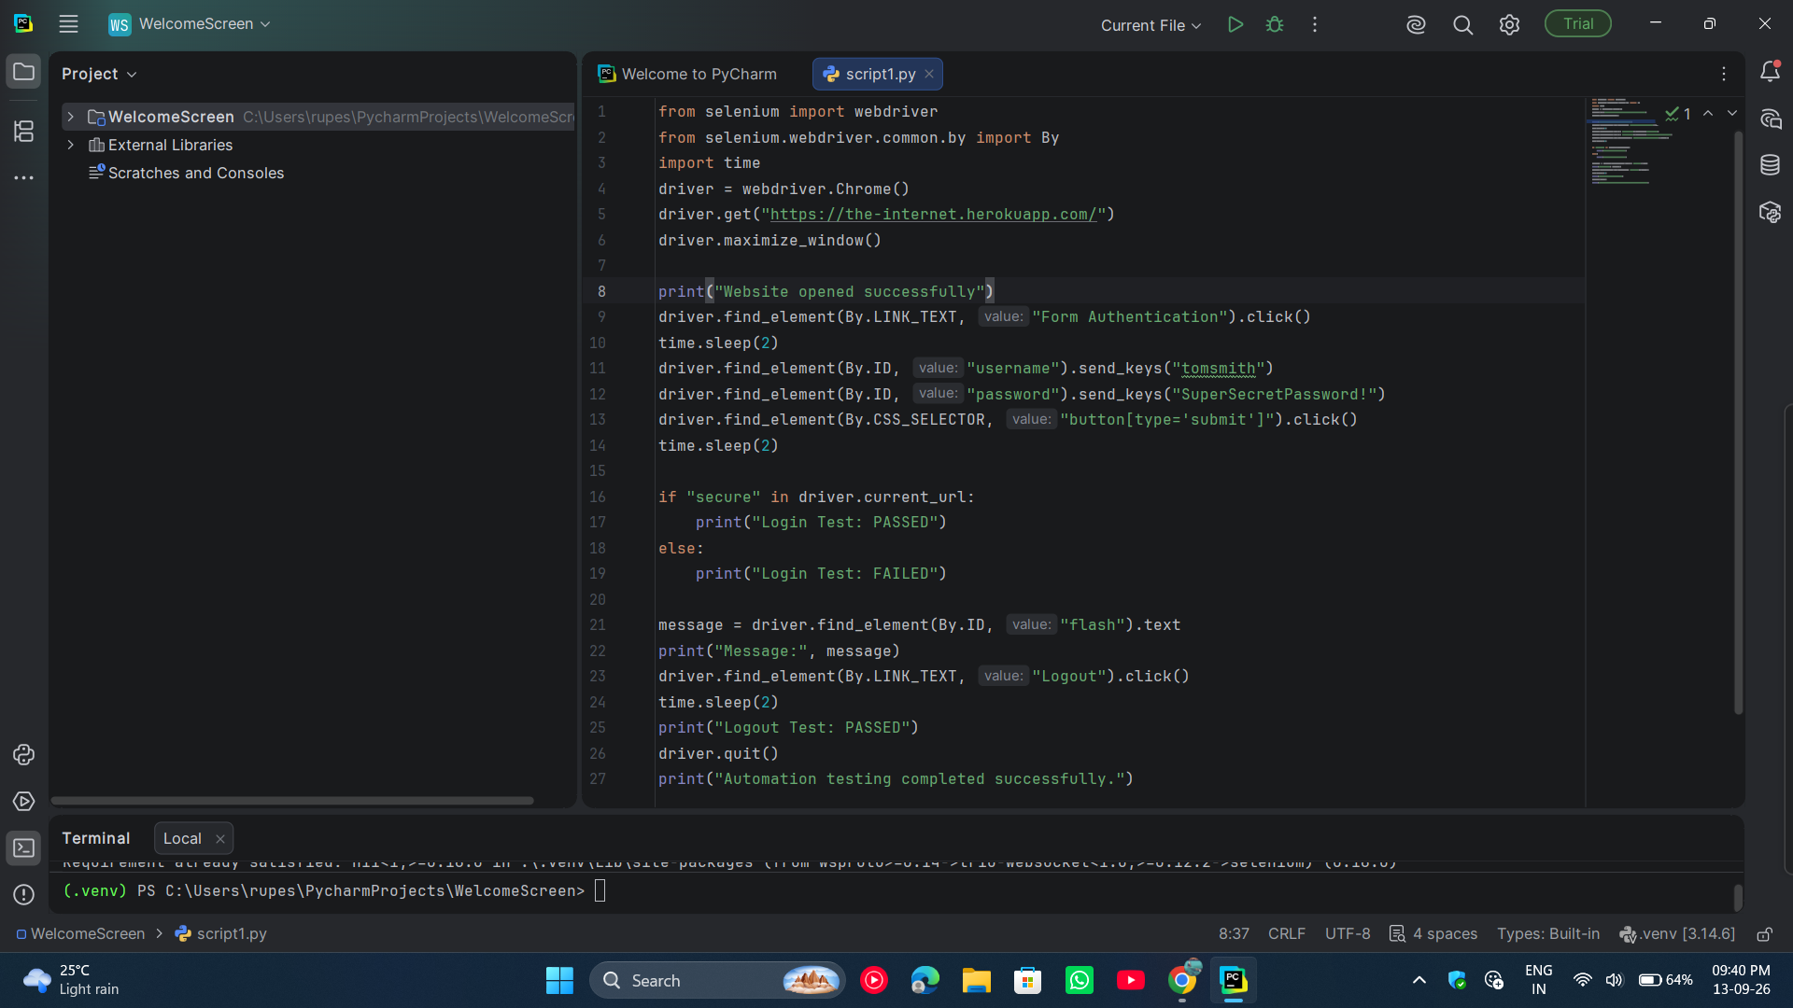
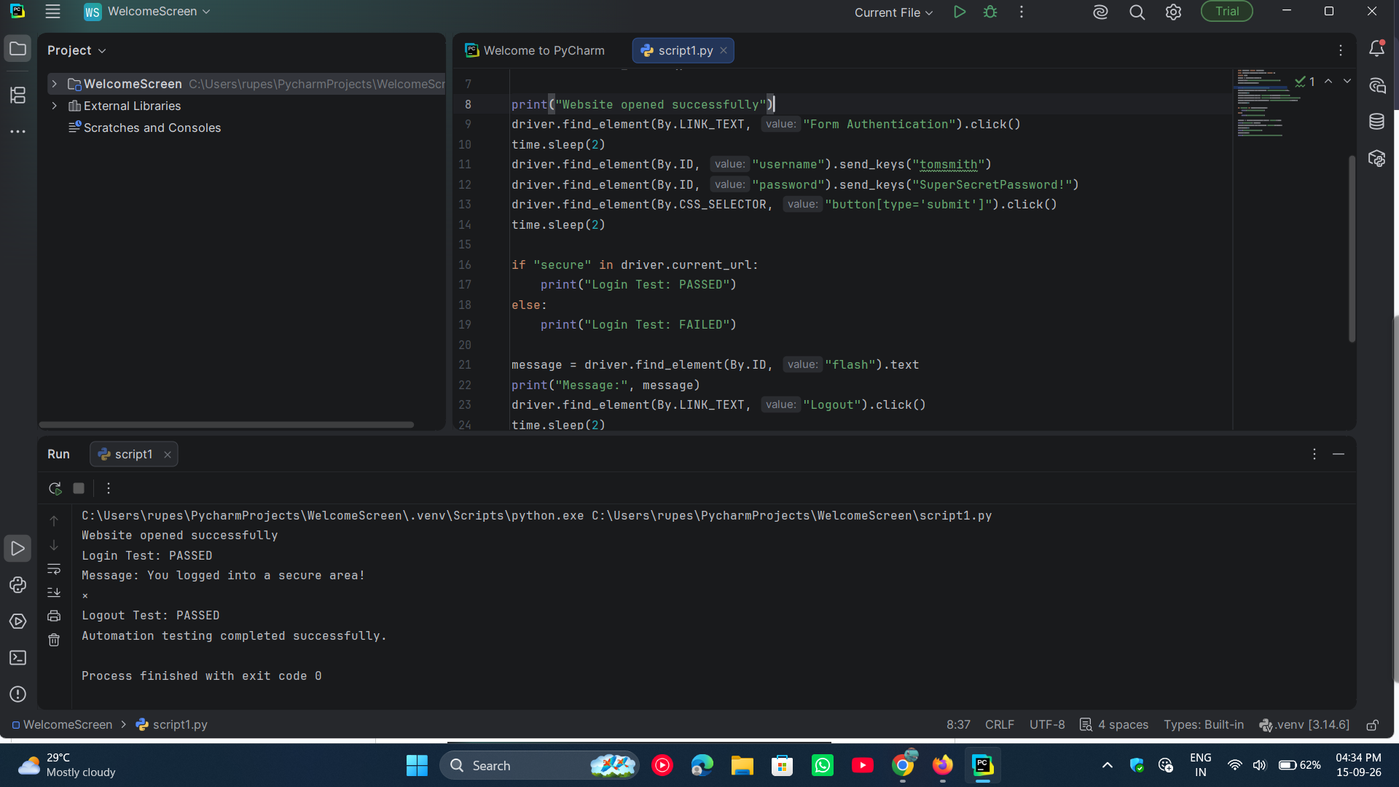

● Scenario ID: 11b
Scenario: Checkboxes selection
Test Steps:
- Open PyCharm app
- Open PyCharm project
- Open script.py
- Run the Selenium automation script
- Open Chrome and navigate to https://the-internet.herokuapp.com/
- Click Checkboxes
- Identify the two checkboxes
- Select the unchecked checkbox
- Deselect the selected checkbox
- Verify the final checkbox states
- Display the test result
- Close the browser

Screenshots: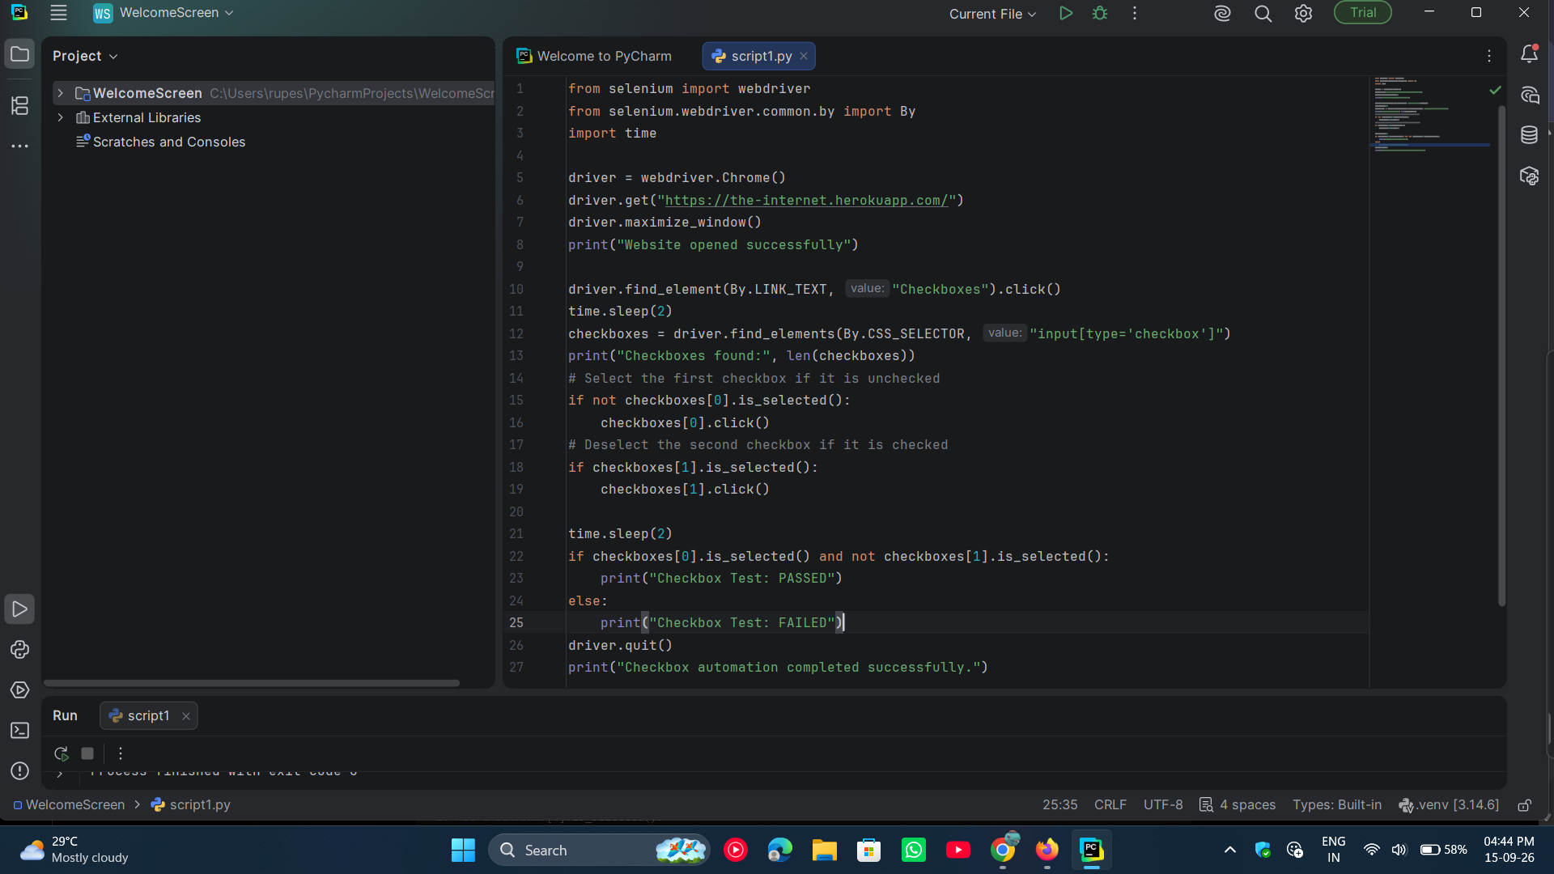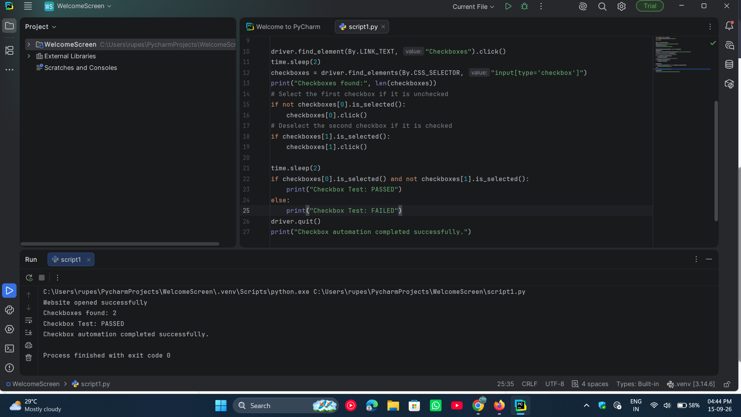

● Scenario ID: 11c
Scenario: Dropdown Selection
Test Steps:
- Open the PyCharm app
- Open PyCharm project
- Open script.py
- Run the Selenium automation script
- Open Chrome and navigate to https://the-internet.herokuapp.com/
- Click Dropdown
- Locate the dropdown list
- Select Option 1
- Verify that Option 1 is selected
- Display the test result
- Close the browser

Screenshots:-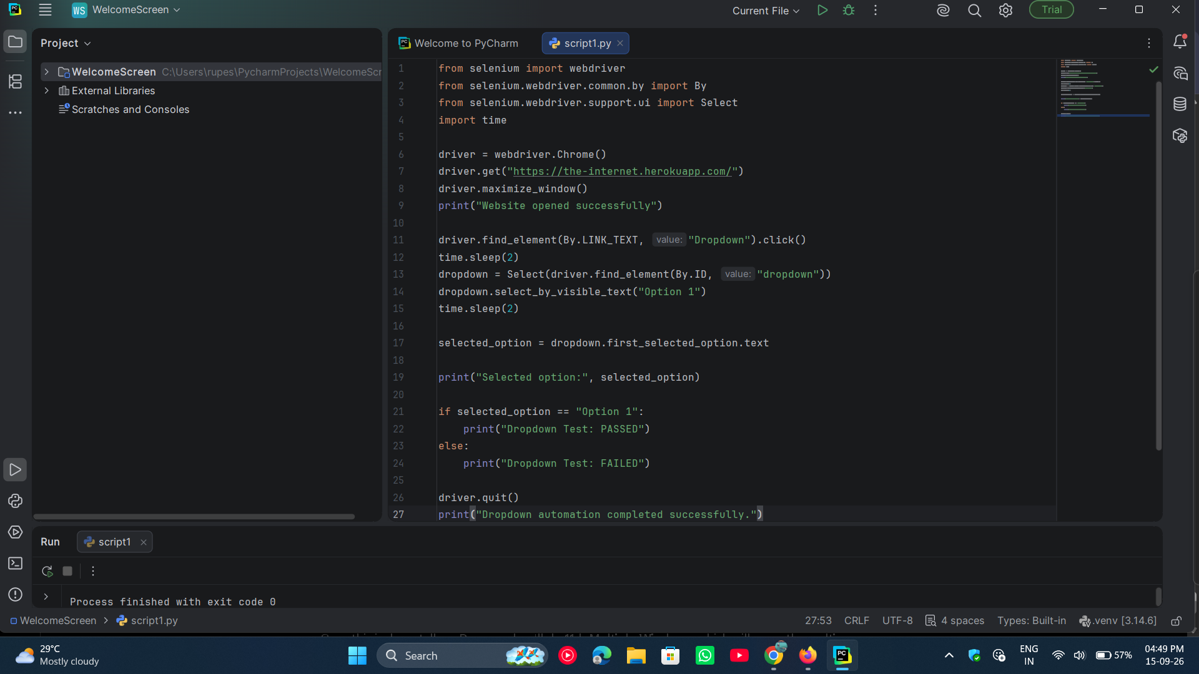

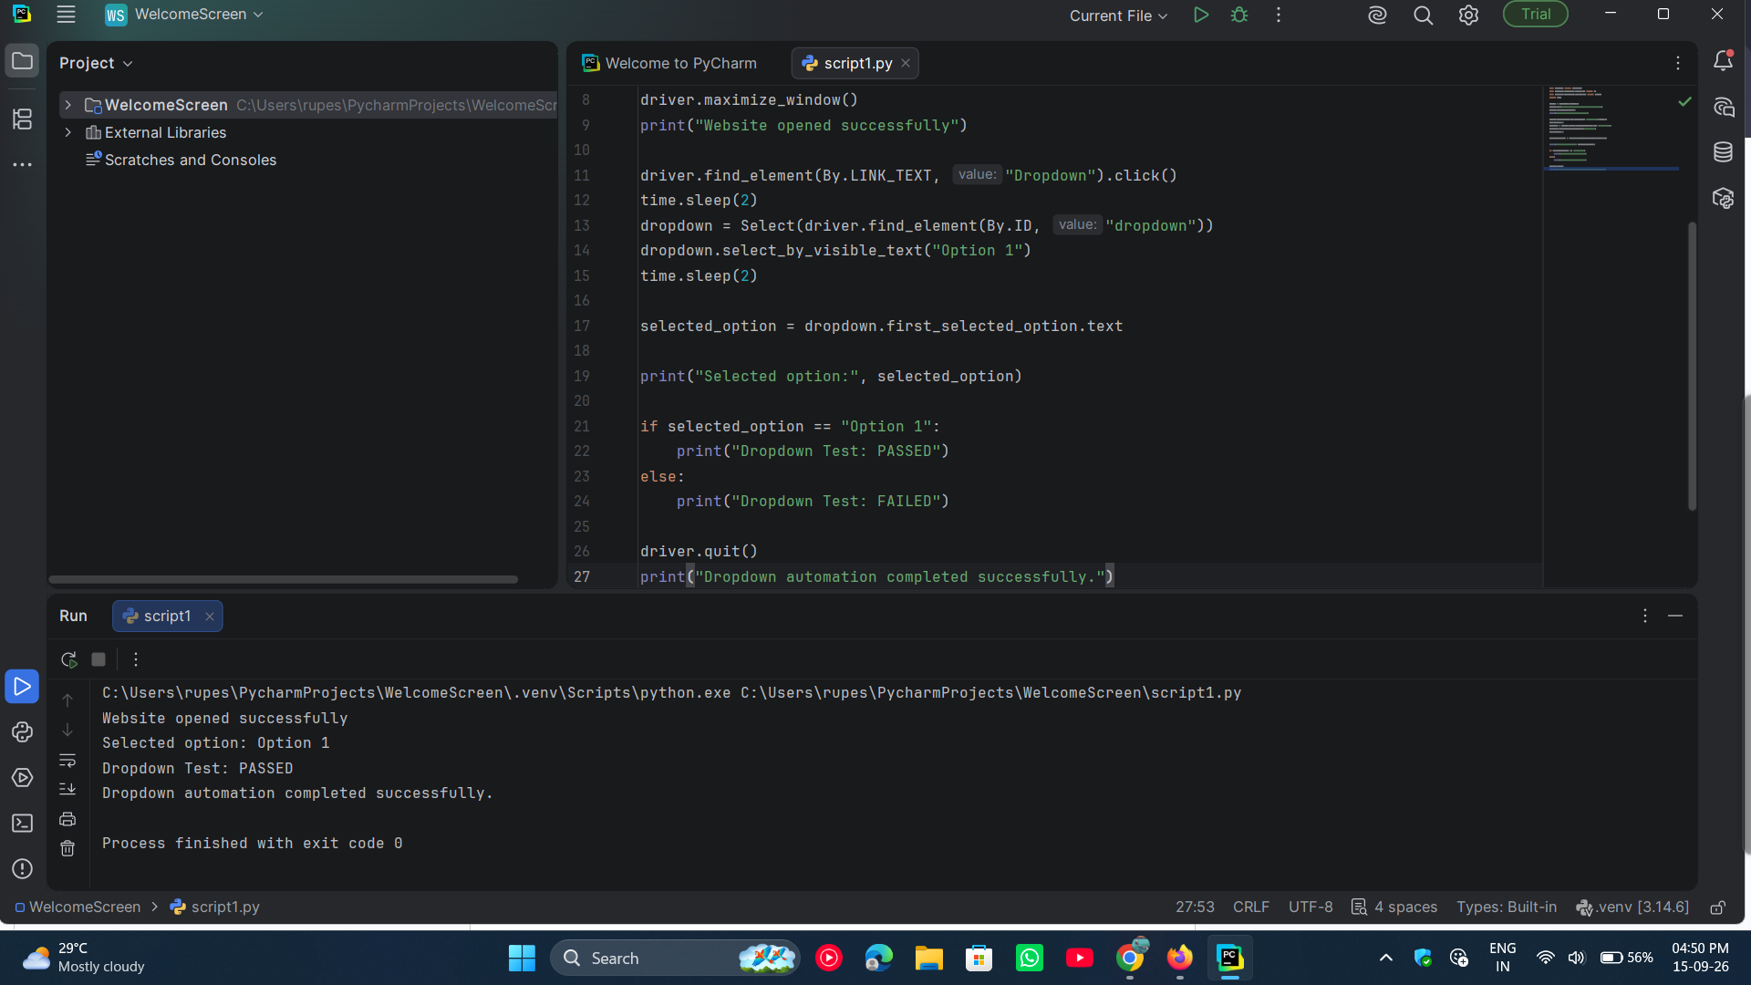

● Scenario ID: 11d
Scenario: Multi-Page / Multiple Window Navigation
Test Steps:
- Open the PyCharm app
- Open PyCharm project
- Open script.py
- Run the Selenium automation script
- Open Chrome and navigate to https://the-internet.herokuapp.com/
- Click Multiple Windows
- Click Click Here to open a new window
- Switch to the new browser window
- Verify the new window title/text
- Switch back to the original window
- Display the test result
- Close the browser

Screenshots: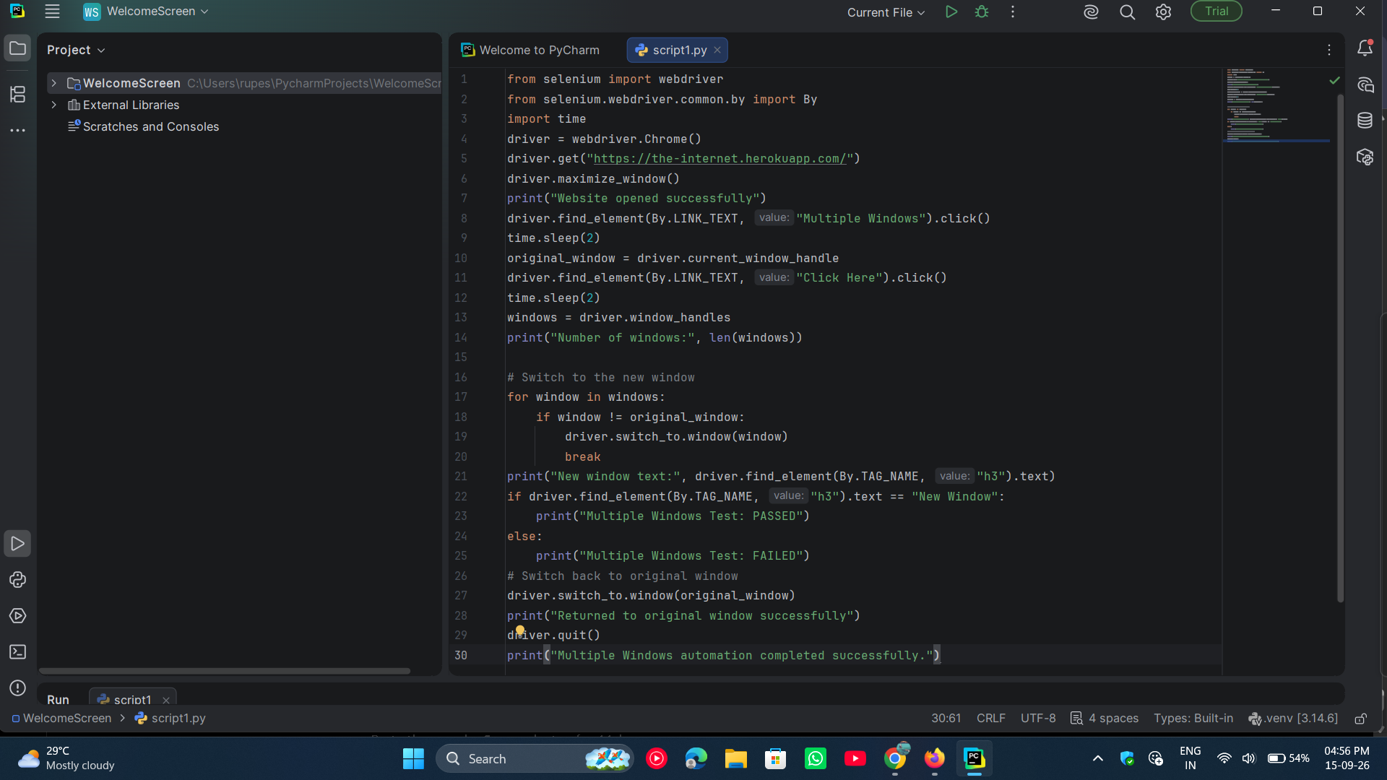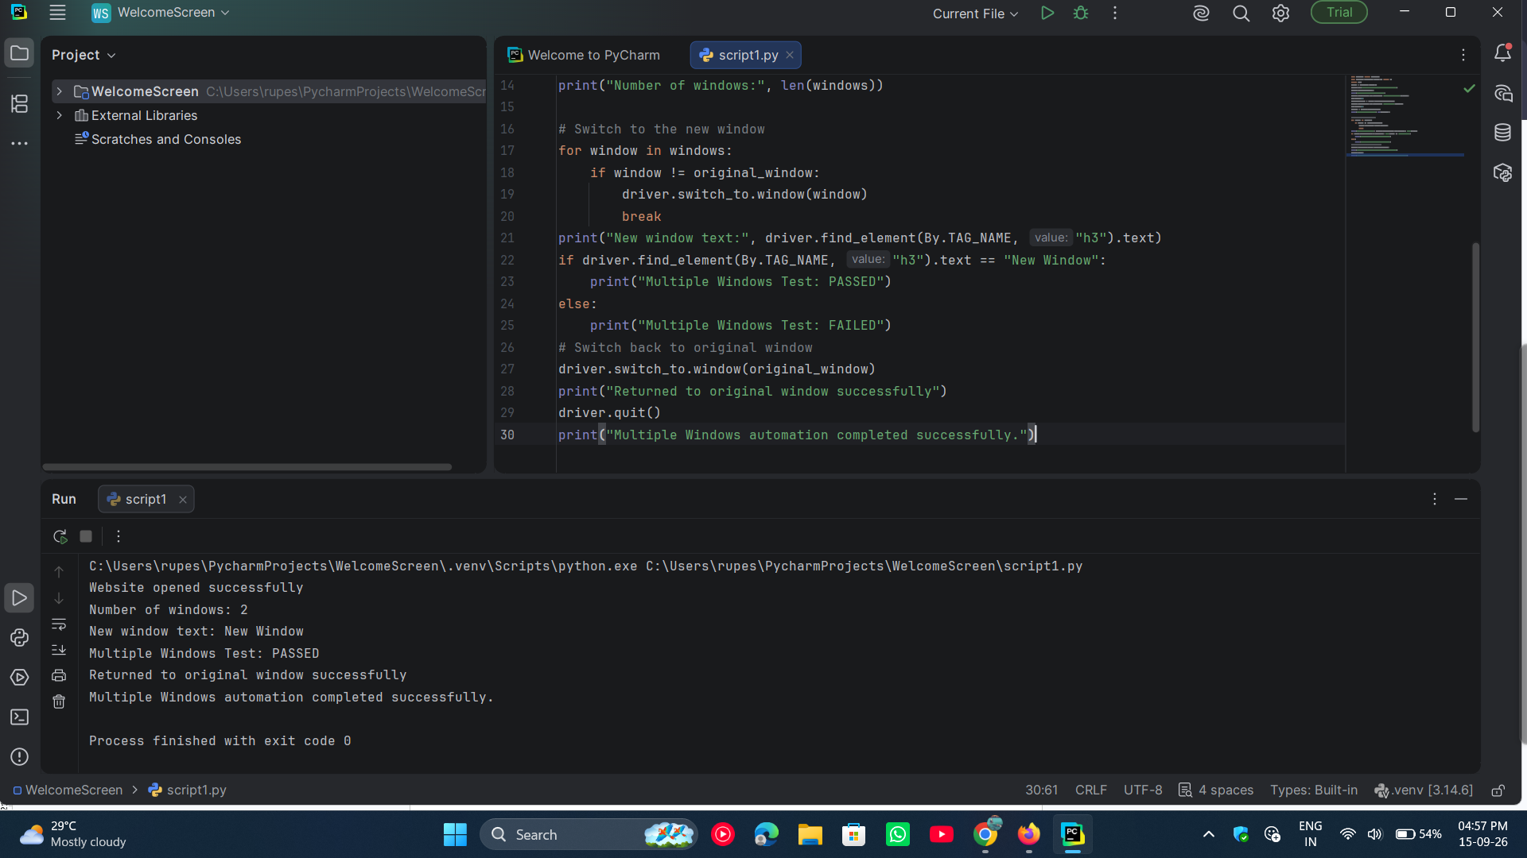

● Scenario ID: 11e
Scenario: Regression Testing of Automated Test Scenarios
Test Steps:
- Open the PyCharm app
- Open the existing Python automation project
- Open script.py
- Run the Selenium automation script
- Verify the website opens successfully
- Verify the Form Authentication scenario
- Verify the Checkboxes scenario
- Verify the Dropdown scenario
- Verify the Multiple Windows scenario
- Check the test results in the PyCharm console
- Confirm that all previously tested functions are working correctly
- Close the browser

Screenshots: